Peoria Humane Society’s
Wine & Whiskers
Event Sponsorship
Proposal

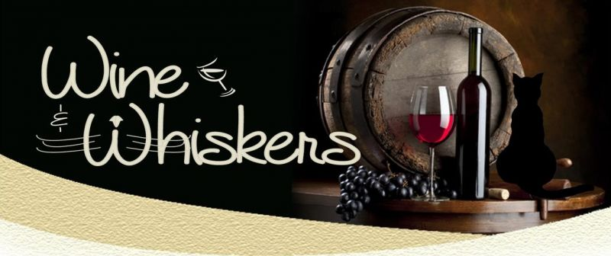

An invitation to help make a difference in the lives of animals in our community.

Peoria Humane Society’s 2021 Wine & Whiskers fundraiser will be an exciting virtual event this year – featuring a fantastic online silent auction. Bidding will take place March 22 – March 26 on BiddingOwl.com.

There are numerous opportunities for your business and your sponsorship to be acknowledged. Please see the attached “Sponsorship Opportunities” page which lists benefits you will enjoy as a Wine & Whiskers sponsor.

The event will be heavily promoted throughout the coming weeks by way of PHS website, Facebook, email, direct mail, auction website, and local media.

In a year full of new challenges, Peoria Humane Society remains steadfast in our commitment to provide critical, life-saving services to companion animals throughout our community. We are asking for your support to assure that no pet goes hungry, suffers from lack of medical care, or finds itself homeless due to its family’s financial struggles.

It is our goal for Wine & Whiskers to raise $20,000 in support of animals who need our help.

We hope you will join us as a sponsor of our 2021 Wine & Whiskers fundraiser.

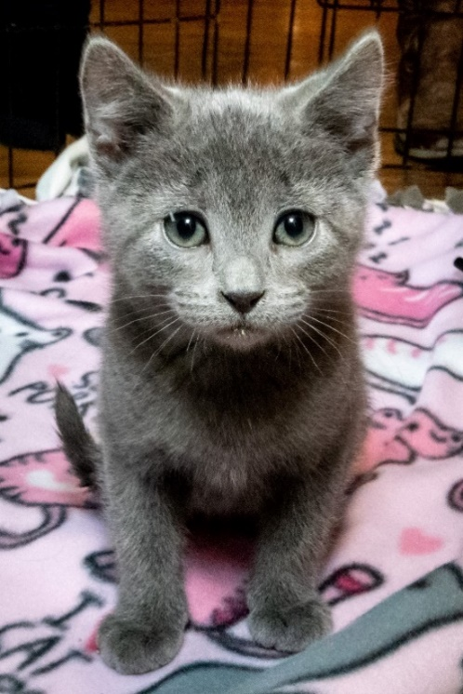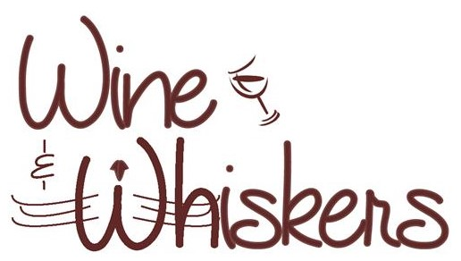
Thank you
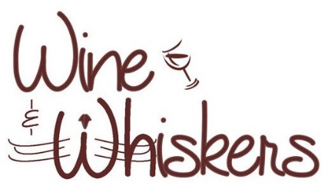
Sponsorship Opportunities

Tuxedo Cat Cabernet - $5000+
- Listing as a top sponsor in promotional materials and advertising (including PHS website, Facebook, printed materials, auction site).

- Your logo and link to your website on PHS website for a six-month duration.

Catastic Chardonnay - $2500
- Listing as a sponsor in promotional materials and advertising (including PHS website, Facebook, printed materials, auction site).

- Your logo and link to your website on PHS website for a three-month duration.

Purrfect Pinot - $1000
- Listing as a sponsor in promotional materials and advertising (including PHS website, Facebook, printed materials, auction site).

- Your logo and link to your website on PHS website.

Meowvelous Merlot - $500
- Listing as a sponsor in promotional materials and advertising (including PHS website, auction site).
Sponsorship Agreement

Please return by March 1, 2021

Company Name_____________________________________________________

Contact Name______________________________________________________

Mailing Address____________________________________________________

Phone________________________ Email_______________________________

Sponsor Level (please select one)
_____ Tuxedo Cat Cabernet $5000
_____ Catastic Chardonnay $2500
_____ Purrfect Pinot $1000
_____ Meowvelous Merlot $500

We would like to donate the following item for the online auction:
_________________________________________________________

Payment Information
_____ Check enclosed
_____ Please email me a PayPal invoice

Please send completed form and payment, if paying by check, to:

Patti Schaffner Email: pschaffner@peoriahs.org
Peoria Humane Society Phone: 309-682-9015
2600 NE Perry
Peoria, IL 61603

